## **Tree Registration**

### **Nomination 1007 RT1007**

Species: *Eucalyptus mannifera* (Red spotted gum)

Location: Block 1 Section 54 Garran

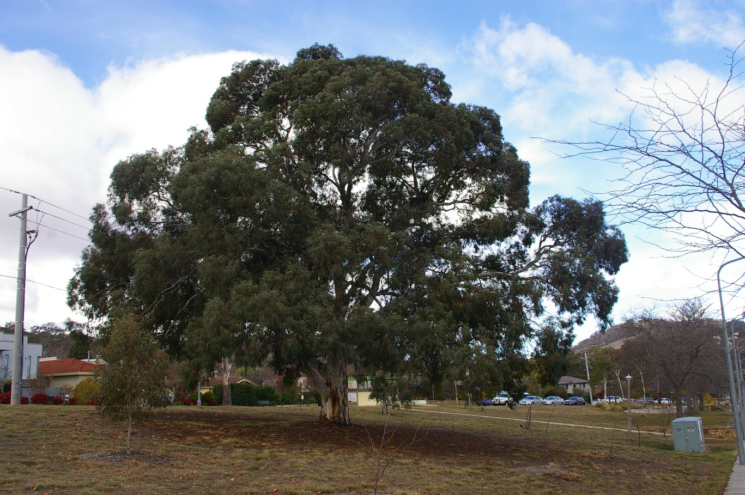

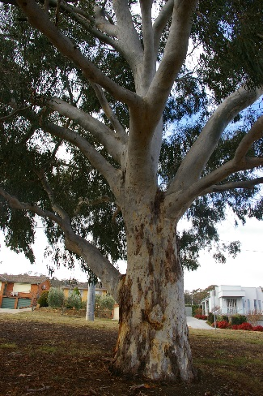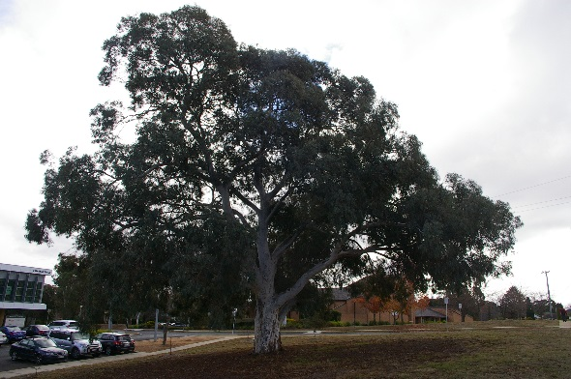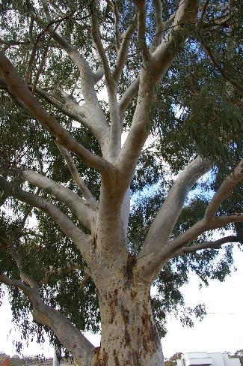

Location of *Eucalyptus mannifera*  RT 1007 in Garran 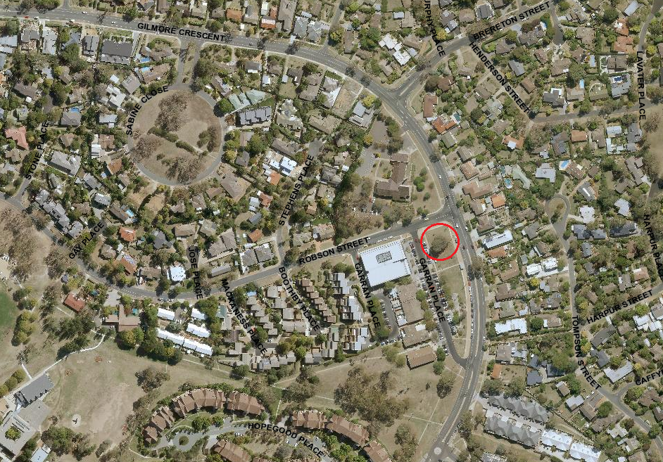

| **Field** | **Details of tree** | |
| --- | --- | --- |
| Street address | Opposite 2 Garran Place Garran | |
| Location | Open space | |
| Botanical name | *Eucalyptus mannifera* | |
| Common name | Red spotted gum | |
| Tree height | 14.0m | |
| Canopy broadest diameter | 22.7m | |
| Description of radial measurement | Diagram of description of radial measurement in relation to north. Radial measurement 1 is located to the north of the tree trunk, radial measurement 2 is located on the east of the tree trunk, radial measurement 3 is located to the south of the tree trunk and radial measurement 4 is located to the west of the tree trunk. | |
| Canopy radial measurement | R1: 10.8m  R2: 10.3m  R3: 7.4m  R4: 12.4m |
| Trunk circumference | 3.45m |
| Number of trunks | 1 |
| Tree Protection Zone | Canopy plus two (2) metres |
| Grid co-ordinates  MGA Zone 55 | X 691615.08  Y 6087011.37 |

**Registration Criteria that presently apply, other criteria may apply after further assessment.**

(2) **Landscape and aesthetic value**

The object of this value is to identify trees that are of particular importance to the community due to their substantial contribution to the surrounding landscape.

A tree may be considered to be of landscape and aesthetic value if it is situated in a prominent location when viewed from a public place and it:

(a) contributes significantly to the surrounding landscape based on its overall form, structure, vigour and aesthetic values; or

(b) represents an outstanding example of the species, including age, size or habit; or

(c) is an exceptional example of a locally native species that reached maturity prior to urban development in its immediate vicinity.

**Statement against the Criteria**

This tree is located on built-up urban area to which the above criteria applies. The tree meets the criteria of Landscape and Aesthetic Value defined under the *Tree Protection Act 2005*.

For the above reasons I am satisfied that the landscape and aesthetic value is high, and that the tree significantly contributes to this value. This beautiful, majestic red spotted gum is a standout feature in the landscape. It is sound and healthy, representing an exceptional example of the species. It contributes significantly to the surrounding landscape on account of its broad spreading, symmetrical canopy and large trunk. It is a worthy inclusion to the ACT Tree Register.

Furthermore, I am not satisfied that the tree meets the criteria for cancellation of registration.

**Number RT1007**

***Eucalyptus mannifera* (red spotted gum)**

## **ACT Tree Register**

**(Registration)**

Pursuant to Division 7.2 of the *Tree Protection Act 2005* as the Conservator of Flora and Fauna and for the reasons stated against the criteria above, I hereby make a decision under section 52 (1) to register the above tree on the ACT Tree Register.

Ian Walker

Conservator of Flora and Fauna 23/5/2019