Tree Registration

Nomination 245 PTR245
Species: Eucalyptus blakelyi (Blakely’s red gum)
Location: Block 5 Section 233 Gungahlin
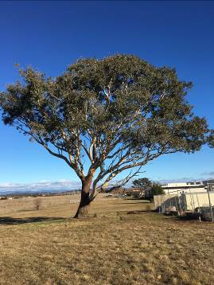
Location of Eucalyptus blakelyi PTR245 in Gungahlin
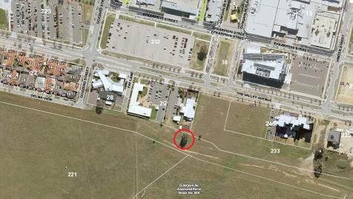
Criteria | Details of tree
Street address | Behind 108 The Valley Avenue Gungahlin
Location on block | Open space
Botanical name | Eucalyptus blakelyi
Common name | Blakely’s red gum
Tree height | 17.0m
Canopy broadest diameter | 18.4m
Description of radial measurement | 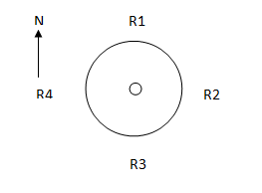
Canopy radial measurement | R1: 8.5m  R2: 12.0m  R3: 9.9m  R4: 2.4m
Trunk circumference | 3.39m
Number of trunks: | 2
Grid co-ordinates:  MGA | X 694272.51  Y 6103968.96

Registration Criteria that presently apply, other criteria may apply after further assessment.
(2) Landscape and aesthetic value
The object of this value is to identify trees that are of particular importance to the community due to their substantial contribution to the surrounding landscape.
A tree may be considered to be of landscape and aesthetic value if it is situated in a prominent location when viewed from a public place and it:
(a) contributes significantly to the surrounding landscape based on its overall form, structure, vigour and aesthetic values; or
(b) represents an outstanding example of the species, including age, size or habit; or
(c) is an exceptional example of a locally native species that reached maturity prior to urban development in its immediate vicinity.
Statement against the Criteria
This impressive Blakely’s red gum is in excellent health and contributes significantly to the surrounding landscape based on its size and form. It is structurally sound and represents an outstanding example of the species given its age and habit. It is also an exceptional example of a local keystone native species that reached maturity prior to urban development in the area. It is highly valued by the community and worthy of recognition through the ACT Tree Register.

Nomination 245
Number PTR245
Eucalyptus blakelyi (Blakely’s red gum)

ACT Tree Register
(Registration)
Pursuant to Division 7.2 of the Tree Protection Act 2005 as the Conservator of Flora and Fauna the following decision has been made under section 52(1) to enter or not enter the above tree(s) to the ACT Tree Register.

Registration

Yes
Conservator of Flora and Fauna 20/7/2018
Requests for further information should be made to:
Tree Protection Unit Telephone: (02) 6207 8145
PO Box 158 Facsimile: (02) 6207 5956
Canberra City, ACT 2601 Email: treeprotection@act.gov.au

