Tree Registration

Nomination 190 PTR190
Species: Eucalyptus melliodora (Yellow box)
Location: Block 4 Section 46 Crace
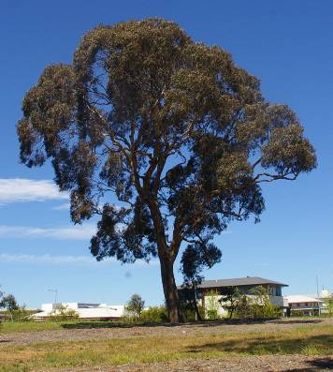
Location of Eucalyptus meliodora PTR 190 in Crace
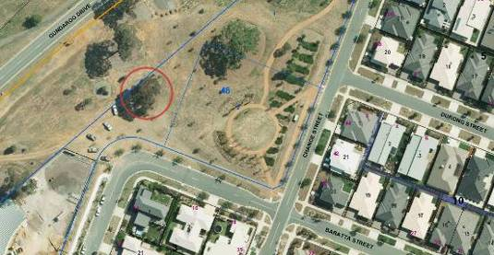
Criteria | Details of tree
Street address | Gundaroo Drive
Location on block | Near Baratta Street, Crace
Botanical name: | Eucalyptus melliodora
Common name: | Yellow box
Tree height | 15.0m
Canopy broadest diameter: | 19.7m
Description of radial measurement | 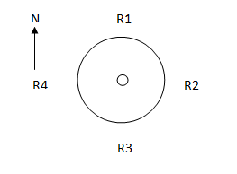
Canopy radial measurement | R1: 12.3m  R2: 10.6m  R3: 7.4m  R4: 8.0m
Trunk circumference: | 2.55m
Number of trunks: | 1
Grid co-ordinates:  MGA | X 691, 481.748  Y 6,102,921.474

Registration Criteria that presently apply, other criteria may apply after further assessment.
(2) Landscape and aesthetic value
The object of this value is to identify trees that are of particular importance to the community due to their substantial contribution to the surrounding landscape.
A tree may be considered to be of landscape and aesthetic value if it is situated in a prominent location when viewed from a public place and it:
(a) contributes significantly to the surrounding landscape based on its overall form, structure, vigour and aesthetic values; or
(b) represents an outstanding example of the species, including age, size or habit; or
(c) is an exceptional example of a locally native species that reached maturity prior to urban development in its immediate vicinity.
Statement against the Criteria
This remnant Yellow box has a beautiful, symmetrical canopy and is very sound and healthy. The tree provides valuable habitat for many local bird species and is an exceptional example of a locally native species that reached maturity prior to urban development in the area. It contributes greatly to the surrounding landscape given its size and prominent location.

Nomination 190
PTR190
Eucalyptus melliodora (Yellow box)

ACT Tree Register
(Registration)
Pursuant to Division 7.2 of the Tree Protection Act 2005 as the Conservator of Flora and Fauna the following decision has been made under section 52(1) to enter or not enter the above tree(s) to the ACT Tree Register

Registration

Yes
Dr A. Lane
Conservator of Flora and Fauna 13/10/2015
Requests for further information should be made to:
Tree Protection Unit Telephone: (02) 6207 8145
PO Box 158 Facsimile: (02) 6207 5956
Canberra City, ACT 2601 Email: treeprotection@act.gov.au

Tree Management Plan

PTR190 Crace
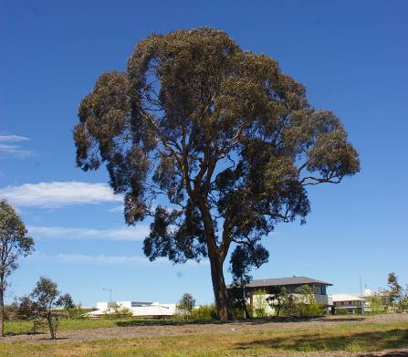
Criteria | Details of tree
Tree Location | Gundaroo Drive Crace
Identification number | PTR190
Botanical Name | Eucalyptus melliodora
Common Name | Yellow box
Height | 15.0m
Trunk circumference at 1 metre | 2.55m
Canopy diameter | 19.7m
Past damage or disturbance | N/A
Current Growth stage | Mature
Risk Mitigation | Regular inspections/as per specific conditions.
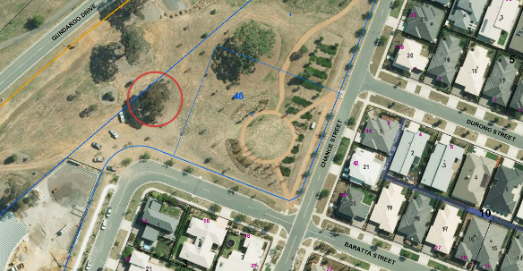

Site Description
- The tree is located between Gundaroo Drive and Baratta Street, Crace.
- The tree is surrounded by a mulch basin.

Specific Conditions

Management responsibility
- Ensuring trees in high use urban areas continue to be inspected for health, condition and safety and are maintained as required;
- Ensuring trees are pruned with the aim of protecting public utilities, enhancing public safety and urban amenity, and improving or maintaining tree health as required;
- Carrying out remedial tree surgery and the removal of fallen or broken timber following storm events;
- Seek approval from the Conservator of Flora and Fauna (the Conservator) when required (see below).
Monitoring
Monitoring of a registered tree shall be undertaken in line with regional priorities by a qualified Arborist with a level (III) to inspect branch unions and parrot damage.
Minor pruning
Minor pruning of a registered tree shall only be undertaken by a qualified Arborist with a level (III) certificate using current Australian Standard 4373 Pruning of amenity trees (AS-4373). Minor pruning does not require approval from the Conservator.
Section 13 (2) of the Tree Protection Act 2005 (the Act) states that minor pruning means pruning (other than lopping or pollarding) done in accordance with AS4373 that-
  - Only involves removing deadwood; or
  - Does not involve removing any limbs that have a diameter greater than 50mm; or
  - Is the first pruning in the calendar year, affects less than 10% of the canopy and does not alter the overall shape of the canopy.

Major pruning
Major pruning shall only be undertaken after consultation with the Tree Protection Unit. Pruning of a registered tree shall only be undertaken by a qualified Arborist with a level (III) certificate using current Australian Standard 4373 Pruning of amenity trees (AS-4373).
Section 13 (1) of the Act states that major pruning means pruning other than lopping, pollarding or minor pruning.
Ground works
Ground works within the Tree Protection Zone (TPZ) of a registered tree shall only be permitted after a specific Tree Management Plan has been put forward and approved by the Conservator.
Australian Standard 4970-2009 – Protection of trees on development sites and the
Tree Protection (Guidelines for Tree Management Plans) Determination 2007 should be consulted in the preparation of the Tree Management Plan.
There are plans to duplicate Gundaroo Drive in the future. This tree is to be well protected during the construction of the new lanes. A protection fence must be erected around the tree protection zone (canopy plus 2 metres). No materials are to be stored within the protection fence.

Removal
Removal of a registered tree requires approval from the Conservator. Before approval can be granted the Conservator must agree to the Cancellation of the Registration.
Removal of a registered tree is permitted in emergency situations when removal is necessary and is the only option available to protect the health and safety of people, animals, or public or private property. Urgent Circumstance authorisation must be applied for through the Tree Protection Unit prior to removal. This can be given on the spot or over the phone.
Conservator of Flora and Fauna .....................………... 13/10/15
AGREED

