## **Tree Registration**

### **Nomination 1015 RT1015**

Species: *Eucalyptus mannifera* (Red spotted gum)

Location: Block 20 Section 68 Taylor

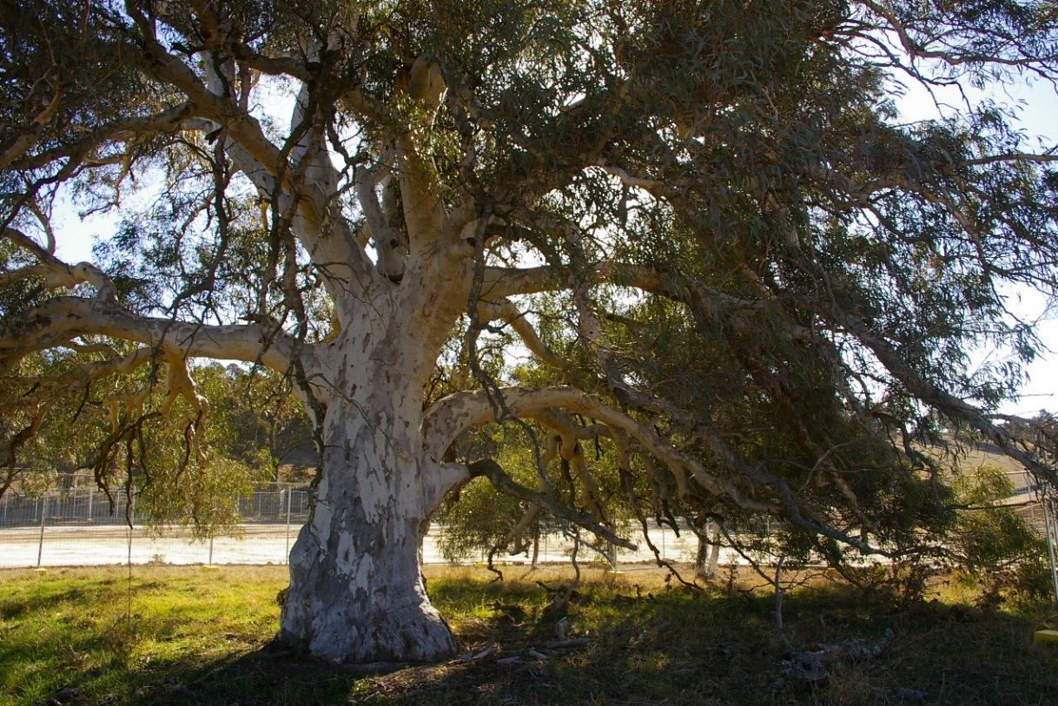

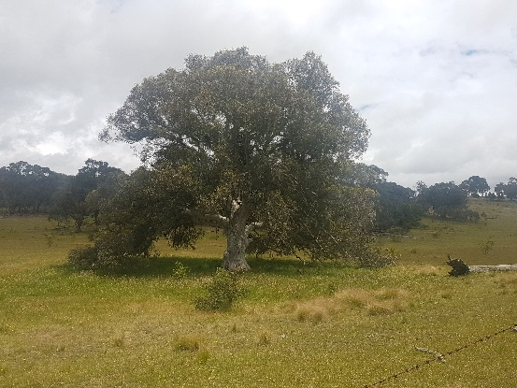 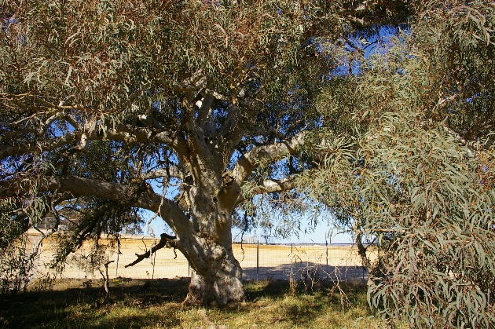

Location of *Eucalyptus mannifera*  RT1015 in Taylor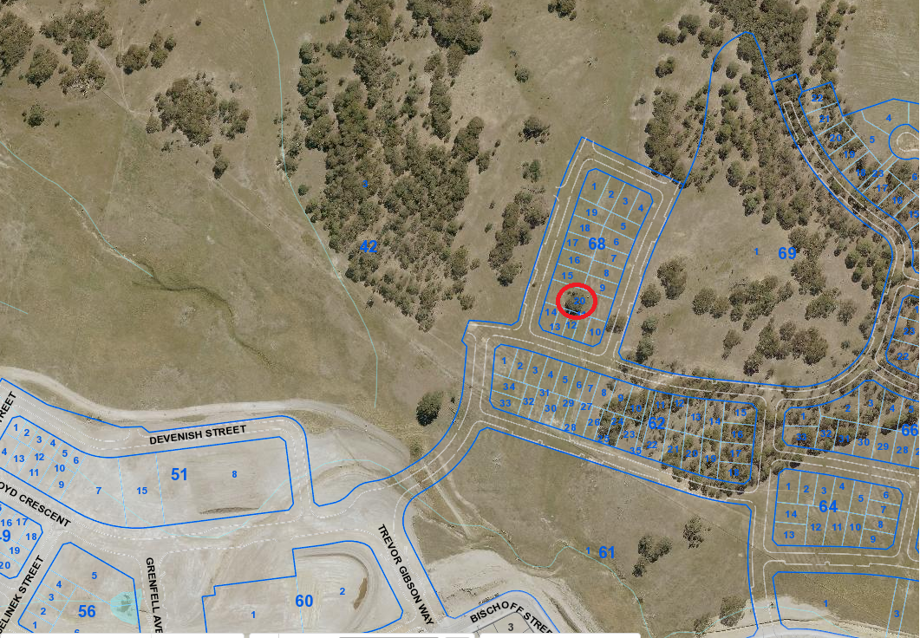

| **Field** | **Details of tree** | |
| --- | --- | --- |
| Street address | Adjacent to 6 Crone Terrace | |
| Location | Block 20 Section 68 Taylor - laneway | |
| Botanical name | *Eucalyptus mannifera* | |
| Common name | Red spotted gum | |
| Tree height | 13.0m | |
| Canopy broadest diameter | 18.6m | |
| Description of radial measurement | Diagram of description of radial measurement in relation to north. Radial measurement 1 is located to the north of the tree trunk, radial measurement 2 is located on the east of the tree trunk, radial measurement 3 is located to the south of the tree trunk and radial measurement 4 is located to the west of the tree trunk. | |
| Canopy radial measurement | R1: 10.0m  R2: 7.7m  R3: 8.6m  R4: 10.0m |
| Trunk circumference | 3.7m |
| Number of trunks | 1 |
| Tree Protection Zone | Canopy plus two (2) metres |
| Grid co-ordinates  MGA GDA 94 | X 692016.32  Y 6108804.09 |

**Registration Criteria that presently apply, other criteria may apply after further assessment.**

(2) **Landscape and aesthetic value**

The object of this value is to identify trees that are of particular importance to the community due to their substantial contribution to the surrounding landscape.

A tree may be considered to be of landscape and aesthetic value if it is situated in a prominent location when viewed from a public place and it:

(a) contributes significantly to the surrounding landscape based on its overall form, structure, vigour and aesthetic values; or

(b) represents an outstanding example of the species, including age, size or habit; or

(c) is an exceptional example of a locally native species that reached maturity prior to urban development in its immediate vicinity.

**Statement against the Criteria**

This tree is located on built-up urban area to which the above criteria applies. The tree meets the criteria of landscape and aesthetic value defined under the *Tree Protection Act 2005*.

This magnificent red spotted gum tree contributes to the surrounding landscape with its evenly domed canopy and large branches weeping down to the ground. It represents an exceptional example of a local keystone native species that reached maturity prior to urban development in the area.

For the above reasons I am satisfied that the landscape and aesthetic value is high, and that the tree significantly contributes to this value.

Furthermore, I am not satisfied that the tree meets the criteria for cancellation of registration.

**Number RT1015**

***Eucalyptus mannifera* (red spotted gum)**

## **ACT Tree Register**

**(Registration)**

Pursuant to Division 7.2 of the *Tree Protection Act 2005* as the Conservator of Flora and Fauna and for the reasons stated against the criteria above, I hereby make a decision under section 52 (1) to register the above tree on the ACT Tree Register.

Ian Walker

Conservator of Flora and Fauna 8 / 7 / 2019