Tree Registration

Nomination 238 Tree Number PTR238
Species: Eucalyptus bridgesiana (Apple box)
Location: Block 6 Section 2 Molonglo
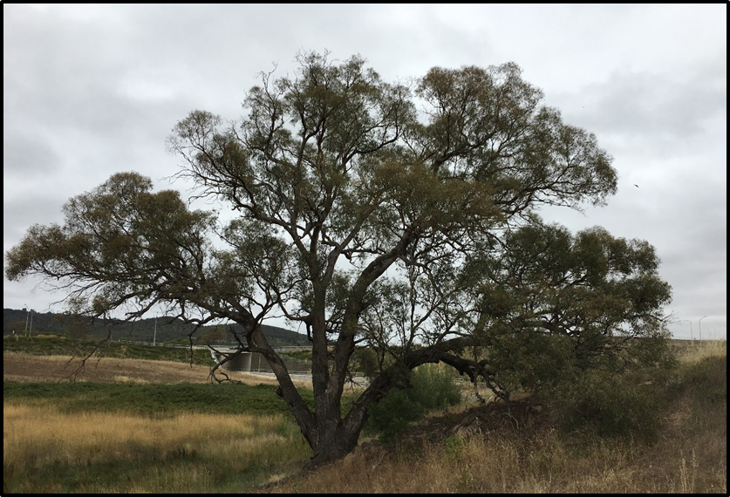
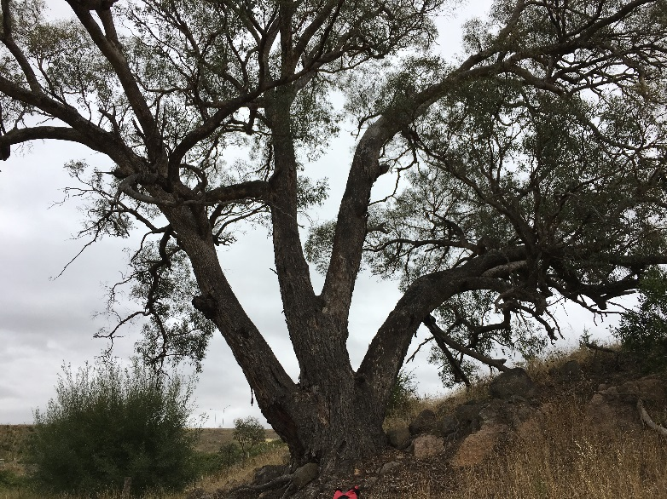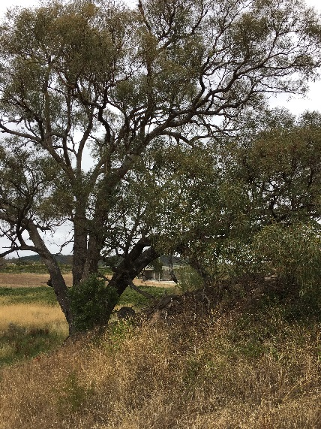

Location of Eucalyptus bridgesiana PTR 238 in Molonglo
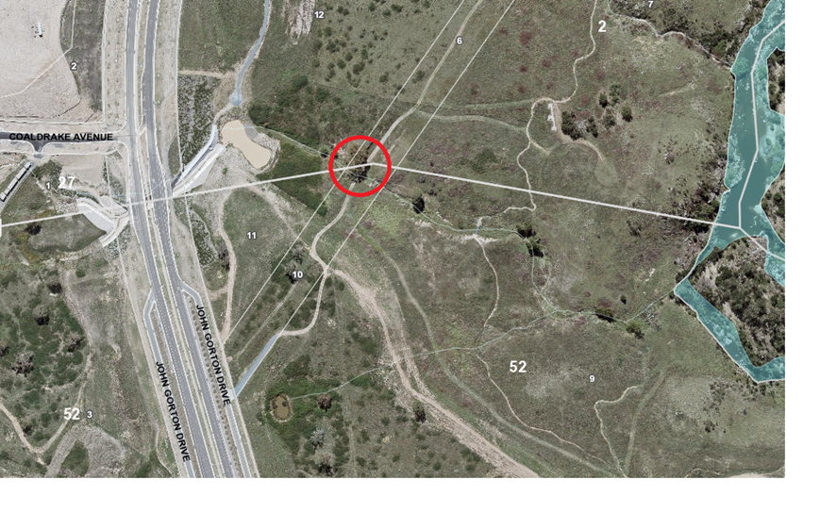
Criteria | Details of tree
Street address | Off John Gorton Drive
Location on block | Adjacent to creek
Botanical name: | Eucalyptus bridgesiana
Common name: | Apple box
Tree height | 18.0m
Canopy broadest diameter: | 29.5m
Description of radial measurement | 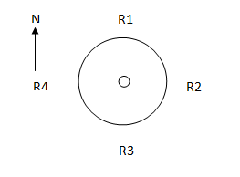
Canopy radial measurement | R1: 14.5m  R2: 10.7m  R3: 15.0m  R4: 11.0m
Trunk circumference: | 6.32m
Number of trunks: | 4
Grid co-ordinates:  MGA | X 684846.37  Y 6090861.52

Registration Criteria that presently apply, other criteria may apply after further assessment.
(2) Landscape and aesthetic value
The object of this value is to identify trees that are of particular importance to the community due to their substantial contribution to the surrounding landscape.
A tree may be considered to be of landscape and aesthetic value if it is situated in a prominent location when viewed from a public place and it:
(a) contributes significantly to the surrounding landscape based on its overall form, structure, vigour and aesthetic values; or
(b) represents an outstanding example of the species, including age, size or habit; or
(c) is an exceptional example of a locally native species that reached maturity prior to urban development in its immediate vicinity.
Statement against the Criteria
This remnant apple box has a sculptural, wide spreading canopy that contributes significantly to the surrounding landscape. It is an exceptional example of the species and represents a locally native species that has reached maturity prior to urban development in the area. The tree is in excellent health and is adjacent to the Molonglo River Reserve. It has been included on the ACT Tree Register in recognition of its landscape and aesthetic value.

Nomination 238
Number PTR238
Eucalyptus bridgesiana (Apple box)

ACT Tree Register
(Registration)
Pursuant to Division 7.2 of the Tree Protection Act 2005 as the Conservator of Flora and Fauna the following decision has been made under section 52(1) to enter or not enter the above tree(s) to the ACT Tree Register

Registration

Yes
Conservator of Flora and Fauna 17/4/2018
Requests for further information should be made to:
Tree Protection Unit Telephone: (02) 6207 8145
PO Box 158 Facsimile: (02) 6207 5956
Canberra City, ACT 2601 Email: treeprotection@act.gov.au

