Tree Registration

Nomination 80 PTR080B
Species: Eucalyptus melliodora (Yellow Box)
Location: Block 10 Section 575 Chisholm
Photo of tree:
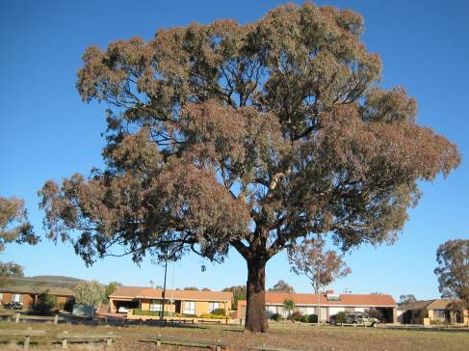
Photo showing location of Eucalyptus melliodora PTR080B Chisholm
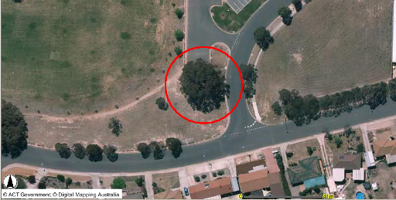

Criteria | Details of tree
Street address | Corner of Mead and Proctor Streets Chisholm
Location on block | Located on the verge at the corner of Mead and Proctor Street Chisholm
Botanical name: | Eucalyptus melliodora
Common name: | Yellow Box
Tree height | 17.5m
Canopy broadest diameter: | 24.0m
Description of radial measurement | N  R1  R2  R4  R3
Canopy radial measurement | R1: 11.0m  R2: 12.0m  R3: 12.0m  R4: 12.0m
Trunk circumference: | 3.6m
Number of trunks: | 1
Grid co-ordinates:  MGA | E 693124  N 6078849

Registration Criteria that presently apply, other criteria may apply after further assessment.
(2) Landscape and aesthetic value
The object of this value is to identify trees that are of particular importance to the community due to their substantial contribution to the surrounding landscape.
A tree may be considered to be of landscape and aesthetic value if it is situated in a prominent location when viewed from a public place and it:
(a) contributes significantly to the surrounding landscape based on its overall form, structure, vigour and aesthetic values; or
(b) represents an outstanding example of the species, including age, size or habit; or
(c) is an exceptional example of a locally native species that reached maturity prior to urban development in its immediate vicinity.
Statement against the Criteria
This remnant Eucalyptus melliodora is located on the verge adjacent to Mead and Proctor Streets in Chisholm. The tree is an exceptional example of a local native species that reached maturity prior to urban development. The tree has a single trunk and a large symmetrical canopy. The tree is very prominent and provides an important feature within the landscape.

Nomination 80
Number PTR080B
Eucalyptus melliodora (Yellow Box)

ACT Tree Register
(Registration)
Pursuant to Division 7.2 of the Tree Protection Act 2005 as the Conservator of Flora and Fauna the following decision has been made under section 52(1) to enter or not enter the above tree(s) in the ACT Tree Register

Registration: Yes
John Meyer
A/g Conservator of Flora and Fauna 16/09/2011
Requests for further information should be made to:
Tree Protection Unit Telephone: (02) 6207 8145
PO Box 158 Facsimile: (02) 6207 5956
Canberra City, ACT 2601 Email: treeprotection@act.gov.au

