Tree Registration

Nomination 246 PTR246
Species: Eucalyptus mannifera (Red spotted gum)
Location: Block 1 Section 18 Curtin
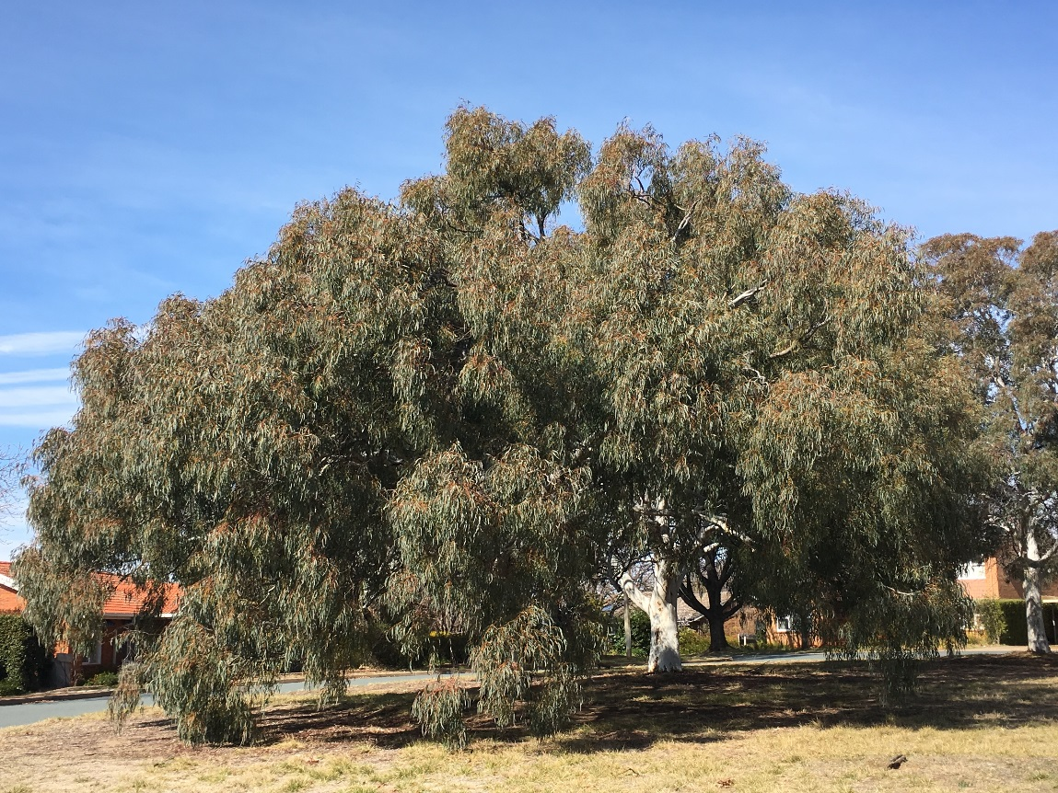
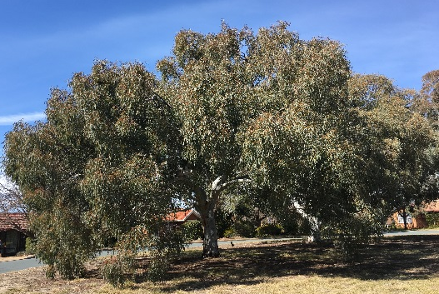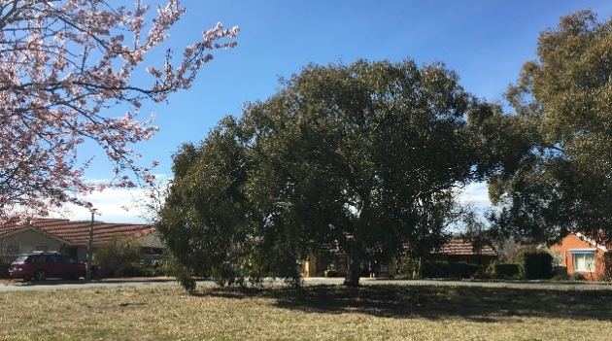
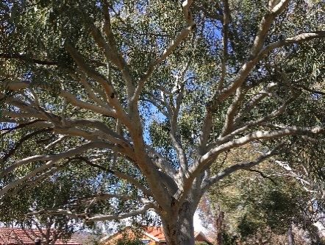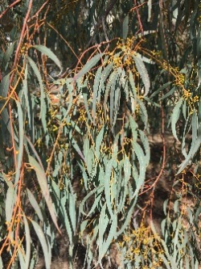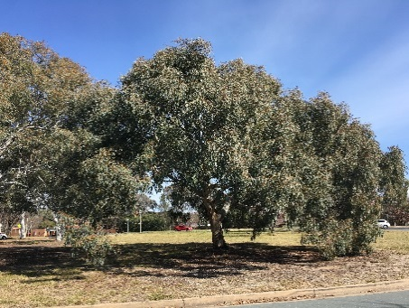
Location of Eucalyptus mannifera PTR246 in Curtin
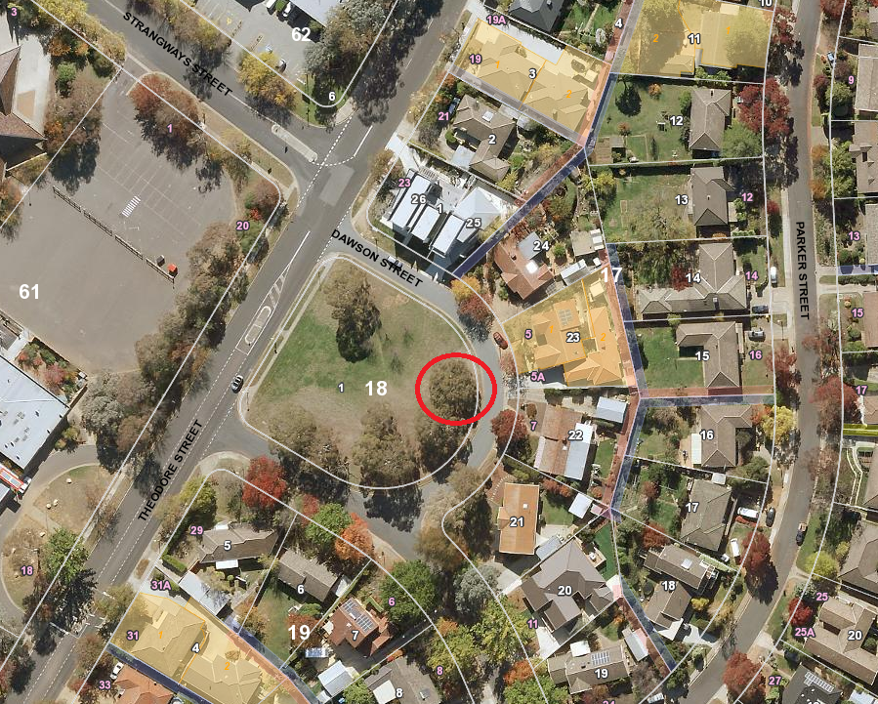
Criteria | Details of tree
Street address | Opposite 7 Dawson Street Curtin
Location on block | In median opposite homes
Botanical name | Eucalyptus mannifera
Common name | Red spotted gum
Tree height | 8.2m
Canopy broadest diameter | 14.0m
Description of radial measurement | 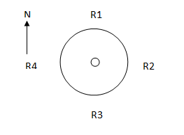
Canopy radial measurement | R1: 7.0m  R2: 7.0m  R3: 7.0m  R4: 7.0m
Trunk circumference | 1.57m
Number of trunks: | 1
Grid co-ordinates:  MGA | X 689330.4  Y 6088613.5

Registration Criteria that presently apply, other criteria may apply after further assessment.
(2) Landscape and aesthetic value
The object of this value is to identify trees that are of particular importance to the community due to their substantial contribution to the surrounding landscape.
A tree may be considered to be of landscape and aesthetic value if it is situated in a prominent location when viewed from a public place and it:
(a) contributes significantly to the surrounding landscape based on its overall form, structure, vigour and aesthetic values; or
(b) represents an outstanding example of the species, including age, size or habit; or
(c) is an exceptional example of a locally native species that reached maturity prior to urban development in its immediate vicinity.
Statement against the Criteria
This beautiful red spotted gum has a symmetrical canopy and an exceptional weeping habit. It is sound and healthy and contributes greatly to the surrounding landscape. Having never been pruned, it represents an outstanding example of the species in its natural form. Red spotted gum is endemic to the Canberra region and this particular individual is treasured by the surrounding residents. It is a worthy addition to the ACT Tree Register.

Nomination 246
Number PTR246
Eucalyptus mannifera (red spotted gum)

ACT Tree Register
(Registration)
Pursuant to Division 7.2 of the Tree Protection Act 2005 as the Conservator of Flora and Fauna the following decision has been made under section 52(1) to enter or not enter the above tree(s) to the ACT Tree Register

Registration

Yes
Conservator of Flora and Fauna 23/8/2018
Requests for further information should be made to:
Tree Protection Unit Telephone: (02) 6207 8145
PO Box 158 Facsimile: (02) 6207 5956
Canberra City, ACT 2601 Email: treeprotection@act.gov.au

