Tree Registration

Nomination 123 Tree Number PTR123
Species: Eucalyptus melliodora (Yellow Box)
Location: Section 46 Amaroo
Photo of tree:
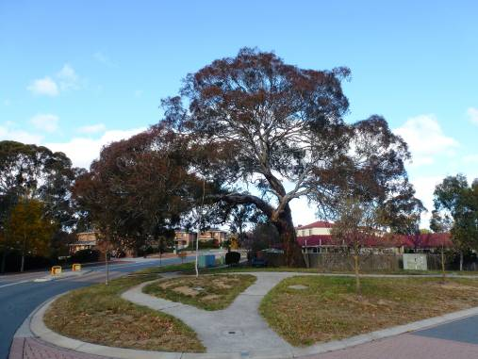
Photo showing location of Eucalyptus melliodora PTR 123 in Amaroo
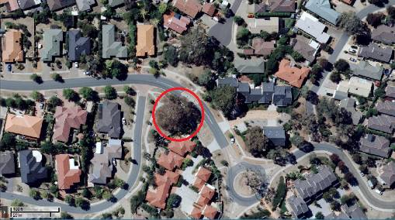
Criteria | Details of tree
Street address | Corner of Lander Crescent and Roderick Street
Location on block | Located on the street verge at corner of Lander Crescent and Roderick Street
Botanical name: | Eucalyptus melliodora
Common name: | Yellow Box
Tree height | 20.0m
Canopy broadest diameter: | 27.5m
Description of radial measurement | N  R1  R2  R4  R3
Canopy radial measurement | R1: 17.5m  R2: 5.5m  R3: 10.5m  R4: 14.0m
Trunk circumference: | 5.2m
Number of trunks: | 1
Grid co-ordinates:  AGD 66 Grid | X 210,477.613  Y 615,733.201

Registration Criteria that presently apply, other criteria may apply after further assessment.
(2) Landscape and aesthetic value
The object of this value is to identify trees that are of particular importance to the community due to their substantial contribution to the surrounding landscape.

A tree may be considered to be of landscape and aesthetic value if it is situated in a prominent location when viewed from a public place and it:
(a) contributes significantly to the surrounding landscape based on its overall form, structure, vigour and aesthetic values; or
(b) represents an outstanding example of the species, including age, size or habit; or
(c) is an exceptional example of a locally native species that reached maturity prior to urban development in its immediate vicinity.

Statement against the Criteria
This Eucalyptus melliodora is an exceptional example of the species located in the suburb of Amaroo. The tree has been selected for inclusion to the ACT Tree Register because of the outstanding aesthetic and landscape values it provides.
This very large tree has a single trunk with a large spreading canopy. It has a very unusual branch habit where the main trunk bends over to form a lateral branch. The tree has a height of approximately 20.0meters, a canopy width of 28.0 metres and a trunk circumference of 5.2metres. The tree is in exceptional health and condition and is located in a very prominent position on the corner of Lander Crescent and Roderick Street Amaroo. Inclusion to the ACT Tree Register may allow this beautiful tree to be appreciated by the wider Canberra community.

Nomination 123
Tree Number PTR123
Eucalyptus melliodora (Yellow box)

ACT Tree Register
(Registration)
Pursuant to Division 7.2 of the Tree Protection Act 2005 as the Conservator of Flora and Fauna the following decision has been made under section 52(1) to enter or not enter the above tree(s) to the ACT Tree Register

Registration

Yes

Alan Traves
A/g Conservator of Flora and Fauna 08/03/2013

Requests for further information should be made to:

Tree Protection Unit Telephone: (02) 6207 8145
PO Box 158 Facsimile: (02) 6207 5956
Canberra City, ACT 2601 Email: treeprotection@act.gov.au

