Tree Registration

Nomination 138 Tree Number PTR138
Species: Quercus robur (English Oak)
Location: Block 14 Section 50 Deakin
Photo of tree:
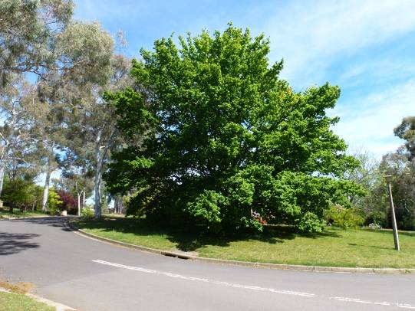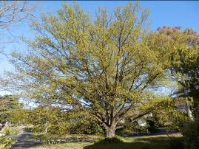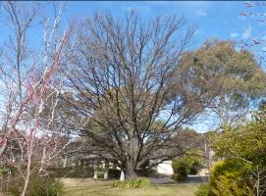

Photo showing location of insert species name PTR138 in Deakin

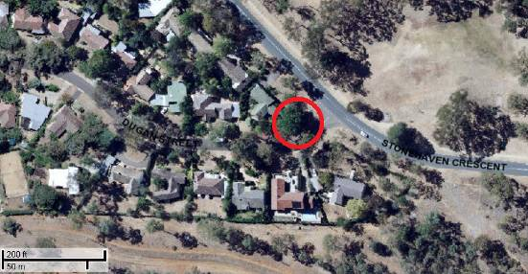

Criteria | Details of tree
Street address | 35 Stonehaven Crescent Deakin
Location on block | Located on the eastern corner of the front yard
Botanical name: | Quercus robur
Common name: | English Oak
Tree height | 22.0m
Canopy broadest diameter: | 12.5m
Description of radial measurement | N  R1  R2  R4  R3
Canopy radial measurement | R1: 11.0m  R2: 11.0m  R3: 11.0m  R4: 11.0m
Trunk circumference: | 3.3m
Number of trunks: | 1
Grid co-ordinates:  AGD 66 Grid | X 209,209.651  Y 599’691.171

Registration Criteria that presently apply, other criteria may apply after further assessment.
(2) Landscape and aesthetic value
The object of this value is to identify trees that are of particular importance to the community due to their substantial contribution to the surrounding landscape.

A tree may be considered to be of landscape and aesthetic value if it is situated in a prominent location when viewed from a public place and it:
(a) contributes significantly to the surrounding landscape based on its overall form, structure, vigour and aesthetic values; or
(b) represents an outstanding example of the species, including age, size or habit.

Statement against the Criteria
This Quercus robur is located in the front yard of 35 Stonehaven Street, Deakin. The tree was planted by the then seven-year-old son of the tree’s owner in 1962. Apparently the young lad collected two acorns which he picked up on the way home from school. The acorns were planted in the front yard and both eventually sprouted. The poorer example of the two was removed allowing this magnificent specimen tree to develop. The tree has a trunk circumference of 3.3 metres, is approximately 15.0 metres tall, and has a canopy spread of 22.0 metres. The tree’s canopy is even and has an excellent branch structure. Over the years the trees owner resisted all attempts from the gardener to have the lower branches removed. This has created a very well balanced specimen tree. It is unusual to see a tree located in someone’s yard which has not been altered to some degree. This tree is a credit to the owner’s foresight and sense of aesthetics in not allowing it to be pruned over the past 50 years. This tree is an exceptional example of the species and is located in a prominent position. It contributes significantly to the surrounding landscape.

Nomination 138
Number PTR138
Quercus robur (English Oak)

ACT Tree Register

(Registration)
Pursuant to Division 7.2 of the Tree Protection Act 2005 as the Conservator of Flora and Fauna the following decision has been made under section 52(1) to enter or not enter the above tree(s) to the ACT Tree Register

Registration

Yes / No / Discuss

Conservator of Flora and Fauna / /2013

Requests for further information should be made to:

Tree Protection Unit Telephone: (02) 6207 8145
PO Box 158 Facsimile: (02) 6207 5956
Canberra City, ACT 2601 Email: treeprotection@act.gov.au

