Tree Registration

Nomination 70 Tree Number PTR049
Species: Eucalyptus melliodora (Yellow box)
Location: Block 76 Section 7 Hume
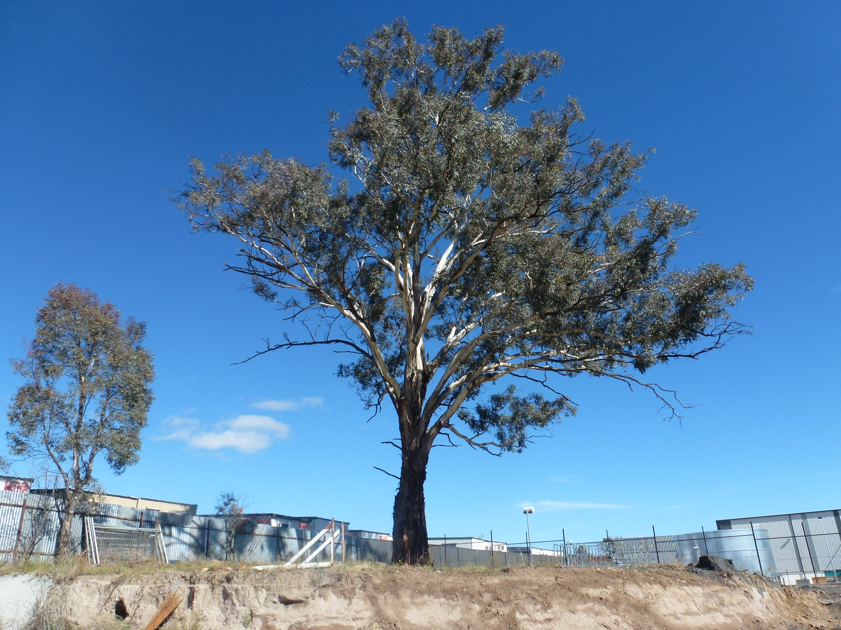
Location of Eucalyptus melliodora PTR049 in Hume
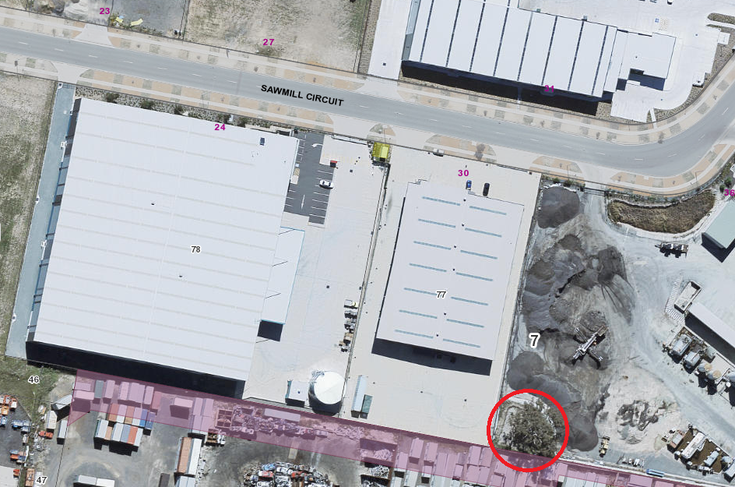
Criteria | Details of tree
Street address | Sawmill Circuit Hume
Location on block | South-west corner of the block
Botanical name: | Eucalyptus melliodora
Common name: | Yellow box
Tree height | 23.0m
Canopy broadest diameter: | 23.0m
Description of radial measurement | 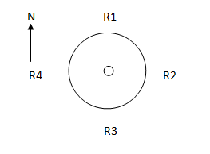
Canopy radial measurement | R1: 13.0m  R2: 10.0m  R3: 10.0m  R4: 9.0m
Trunk circumference: | 3.5m
Number of trunks: | 1
Grid co-ordinates:  MGA | X696347.72  Y 6080423.18

Registration Criteria that presently apply, other criteria may apply after further assessment.
(2) Landscape and aesthetic value
The object of this value is to identify trees that are of particular importance to the community due to their substantial contribution to the surrounding landscape.
A tree may be considered to be of landscape and aesthetic value if it is situated in a prominent location when viewed from a public place and it:
(a) contributes significantly to the surrounding landscape based on its overall form, structure, vigour and aesthetic values; or
(b) represents an outstanding example of the species, including age, size or habit; or
(c) is an exceptional example of a locally native species that reached maturity prior to urban development in its immediate vicinity.
Statement against the Criteria
This Eucalyptus melliodora is located on the south-western side of a block in the newly completed part of Hume industrial estate. The tree was assessed prior to the estate being developed and was identified as being an excellent example of the species. The tree is a local native species which reached maturity prior to urban development in the immediate vicinity and is an important aesthetic landscape feature. When the site was initially inspected the tree stood out as a quality specimen. It was noted for its large size and good vigour and health.
In addition to the aesthetic and landscape contribution, the tree provides habitat opportunities for nesting birds and shade within an otherwise harsh industrial landscape.

Nomination 70
Number PTR49
Eucalyptus melliodora (Yellow box)

ACT Tree Register
(Registration)
Pursuant to Division 7.2 of the Tree Protection Act 2005 as the Conservator of Flora and Fauna the following decision has been made under section 52(1) to enter or not enter the above tree(s) to the ACT Tree Register

Registration

Yes
Conservator of Flora and Fauna 31/7/2012
Requests for further information should be made to:
Tree Protection Unit Telephone: (02) 6207 8145
PO Box 158 Facsimile: (02) 6207 5956
Canberra City, ACT 2601 Email: treeprotection@act.gov.au

Tree Management Plan for Registered Tree

PTR049 Hume Eucalyptus mellidora
Criteria | Details of tree
Tree Location | 36 Sawmill Circuit Hume
Site description | Asphalt processing plant
Identification number | PTR049
Botanical Name | Eucalyptus melliodora
Common Name | Yellow box
Height | 23.0m
Trunk circumference | 3.5mm
Broadest canopy diameter | 23.0m
General health and vigour | Good
Past damage or disturbance | Excavation on two sides of the tree outside the tree protection zone
Current Growth stage | Mature
Tree Quality Classification | Good
Risk Mitigation | Regular inspections and watering in warmer months when necessary

Exposed excavation face - Shotcrete has been sprayed on the exposed batter created by excavation at the tree’s natural drip line, at a minimum, to avoid soil erosion. The work was completed in April 2015.

Regular inspections should be undertaken by a qualified arborist to ensure the tree remains in good condition (Five-year intervals would be considered appropriate).

Minor Pruning or Major Pruning shall only be undertaken after receiving approval from the Conservator of Flora and Fauna (the Conservator) following consultation with the Tree Protection Unit and the lodgement of a Tree Damaging Activity form.
Pruning work on a Registered Tree or a Provisionally Registered Tree shall only be undertaken by a qualified Arborist with a level (IV) certificate or equivalent.

Ground works within the Tree Protection Zone of a Registered Tree shall only be permitted after a Tree Management Plan has been put forward in a Tree Damaging Activity application form and approved by the Conservator.
The Australian Standard 4970-2009 Protection of trees on development sites and the
Tree Protection (Guidelines for Tree Management Plans) Determination 2007 should be consulted in the preparation of the Tree Management Plan.

Replacement / Removal of a registered tree is permitted after notification to the Tree Protection Unit and approval has been granted by the Conservator or delegate of the Conservator either orally or in writing. Cancellation of registration can only be considered if the criteria as set out in the Tree Protection (Criteria for Registration and Cancellation of Registration) Determination 2006 are met.

Watering of the tree will be left to lessee’s discretion. It is recommended that the tree be water during the summer months as required. Restrictions may apply subject to ACTEW and the ACT Government guidelines. In circumstances where water restrictions apply the conditions outlined within the restrictions will prevail. Information regarding water conservation and current restrictions are available on the ACTEW web site. The web address is noted below: http://www.actew.com.au/SaveWaterForLife/WaterRestrictions/current_restrictions.aspx

Penalties for breaches of the Tree Protection Act. There must be strict compliance with the conditions outlined in this Tree Management Plan. Failure to do so may constitute an offence against the Tree Protection Act 2005 which may attract a court imposed penalty of up to $56,000 for an individual and up to $280,000 for a corporation

Delegate of the Conservator of Flora and Fauna .....................………... 12/8/2016

AGREED

Value of penalties is subject to change. These figures are current as of 7 April 2015.

