Tree Registration

Nomination 199 PTR199-Group
Species: Pyrus sp (Pear)
Location: Block 1 Section 92 Amaroo
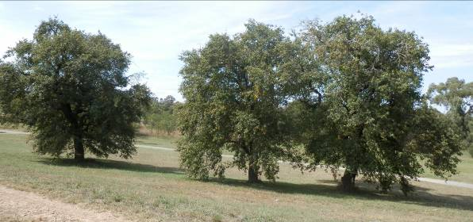
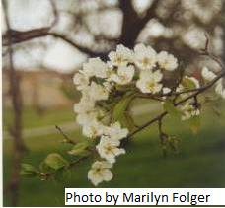
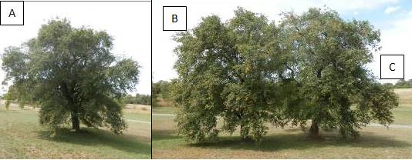

Location of Pyrus sp PTR199-Group in Amaroo
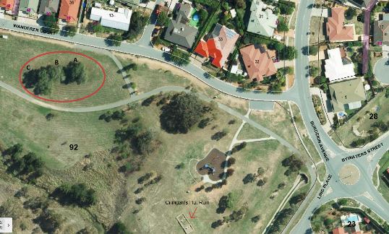
Criteria | Details of tree
Street address | Opposite 34-38 Wanderer Court Amaroo
Location on block | Open space
Botanical name: | Pyrus sp
Common name: | Pear
Tree height | Tree A: 11.5m  Tree B: 12.5m  Tree C: 12.5m
Canopy broadest diameter: | Tree A: 15.5m  Tree B: 12.2m  Tree C: 18.3m
Description of radial measurement | 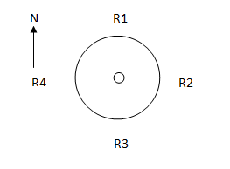
Canopy radial measurement | Tree A  R1: 8.5m  R2: 5.5m  R3: 7.0m  R4: 8.0m  Tree B  R1: 6.1m  R2: 7.2m  R3: 4.5m  R4: 5.0m  Tree C  R1: 7.8m  R2: 6.8m  R3: 10.5m  R4: 7.0m
Trunk circumference: | Tree A: 2.4m  Tree B: 2.0m  Tree C: 2.45m
Number of trunks: | All have 1 trunk
Grid co-ordinates:  MGA Zone 55 | Tree A  X 692946.094  Y 6106060.448  Tree B  X 692933.611  Y6106058.198  Tree C  X 692926.584  Y 6106055.972

Registration Criteria that presently apply, other criteria may apply after further assessment.
(1) Natural or cultural heritage value
The object of this value is to identify trees that are of particular importance to the community due to their intrinsic heritage values.
A tree may be considered to be of natural or cultural heritage value when it is:
(a) associated with a significant public figure or important historical event; or
(b) of high cultural heritage value to the community or cultural group, including trees associated with aboriginal heritage and culture; or
(c) associated with a heritage nominated place and representative of that same historic period.
(2) Landscape and aesthetic value
The object of this value is to identify trees that are of particular importance to the community due to their substantial contribution to the surrounding landscape.
A tree may be considered to be of landscape and aesthetic value if it is situated in a prominent location when viewed from a public place and it:
(a) contributes significantly to the surrounding landscape based on its overall form, structure, vigour and aesthetic values; or
(b) represents an outstanding example of the species, including age, size or habit; or
(c) is an exceptional example of a locally native species that reached maturity prior to urban development in its immediate vicinity.
Statement against the Criteria
These three trees provide a significant link to Canberra’s history. The trees were part of an orchard grown adjacent to the Crinigan’s stone cottage. The cottage and orchard were owned by John and Maria Crinigan who lived on the site from about 1842 until 1863. The pears would have been planted in the mid 19th century, making them approximately 150 years old. Crinigan’s Hut Ruin has been placed on the ACT Heritage Register and lists the pears as a feature intrinsic to the heritage significance of the place.

Nomination 199
Number PTR199-Group
Pyrus sp (Pear)

ACT Tree Register
(Registration)
Pursuant to Division 7.2 of the Tree Protection Act 2005 as the Conservator of Flora and Fauna the following decision has been made under section 52(1) to enter or not enter the above tree(s) to the ACT Tree Register

Registration

Yes
Dr A. Lane
Conservator of Flora and Fauna 22/12/2015
Requests for further information should be made to:
Tree Protection Unit Telephone: (02) 6207 8145
PO Box 158 Facsimile: (02) 6207 5956
Canberra City, ACT 2601 Email: treeprotection@act.gov.au

