Tree Registration

Nomination 124 Tree Number PTR124
Species: Eucalyptus melliodora (Yellow Box)
Location: Block 8 Section 33 Forde
Photo of tree:
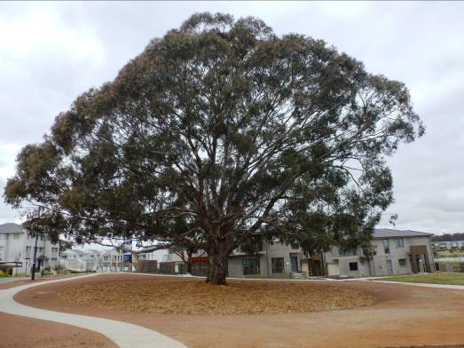
Photo showing location of Eucalyptus melliodora PTR124 in Forde
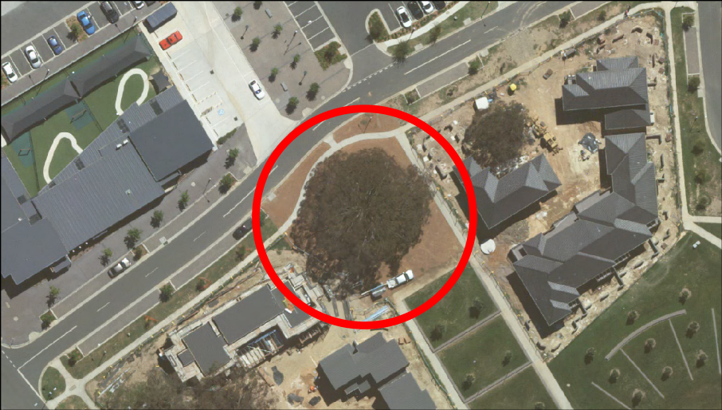
Criteria | Details of tree
Street address | Lomax Street
Location on block | Located in urban open space adjacent to the Forde shopping precinct
Botanical name: | Eucalyptus melliodora
Common name: | Yellow Box
Tree height | 19.0m
Canopy broadest diameter: | 26.7m
Description of radial measurement | N  R1  R2  R4  R3
Canopy radial measurement | R1: 14.7m  R2: 12.5m  R3: 12.0m  R4: 12.7m
Trunk circumference: | 3.6m
Number of trunks: | 1
Grid co-ordinates:  AGD 66 Grid | X 212,117.154  Y 615,979.864

Registration Criteria that presently apply, other criteria may apply after further assessment.
(2) Landscape and aesthetic value
The object of this value is to identify trees that are of particular importance to the community due to their substantial contribution to the surrounding landscape.

A tree may be considered to be of landscape and aesthetic value if it is situated in a prominent location when viewed from a public place and it:
(a) contributes significantly to the surrounding landscape based on its overall form, structure, vigour and aesthetic values; or
(b) represents an outstanding example of the species, including age, size or habit; or
(c) is an exceptional example of a locally native species that reached maturity prior to urban development in its immediate vicinity.
Statement against the Criteria
This Eucalyptus melliodora is arguably the best remnant Eucalypt in Forde. The tree is one of five individual trees located in the new estate, retained as part of the development. The tree has been selected because it is an outstanding specimen which provides a significant aesthetic and landscape contribution. The tree is located in Lomax Street opposite to the local shopping centre in urban open space which flows through to the pond foreshore. It is a central feature of and integrated landscape which incorporates high quality housing and urban open space. It is testimony that endemic remnant trees can be incorporated effectively within an urban environment.
This impressive tree has a single trunk with a large spreading canopy. It has a height of approximately 19.0meters, a canopy width of 26.7 metres and a trunk circumference of 3.6metres.

Nomination 124
Number PTR124
Eucalyptus melliodora (Yellow Box)

ACT Tree Register
(Registration)
Pursuant to Division 7.2 of the Tree Protection Act 2005 as the Conservator of Flora and Fauna the following decision has been made under section 52(1) to enter or not enter the above tree(s) to the ACT Tree Register

Registration

Yes

Alan Traves
A/g Conservator of Flora and Fauna 08/03/2013

Requests for further information should be made to:

Tree Protection Unit Telephone: (02) 6207 8145
PO Box 158 Facsimile: (02) 6207 5956
Canberra City, ACT 2601 Email: treeprotection@act.gov.au

