Tree Registration

Nomination 139 Tree Number PTR139
Species: Cedrus deodara (Deodar Cedar)
Location: Block 9 Section 16 Red Hill
Photo of tree:
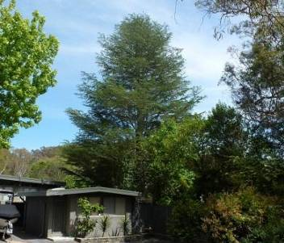
Photo showing location of Cedrus deodara PTR139 in Red Hill
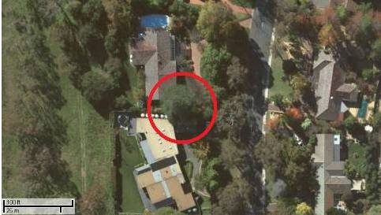

Criteria | Details of tree
Street address | 54 Mugga Way
Location on block | Located on the southern side of the front yard
Botanical name: | Cedrus deodara
Common name: | Deodar Cedar
Tree height | 27.5m
Canopy broadest diameter: | 18.0m
Description of radial measurement | N  R1  R2  R4  R3
Canopy radial measurement | R1: 9.0m  R2: 9.0m  R3: 9.0m  R4: 9.0m
Trunk circumference: | 3.7m
Number of trunks: | 1
Grid co-ordinates:  AGD 66 Grid | X 210,117.421  Y 596,095.712

Registration Criteria that presently apply, other criteria may apply after further assessment.
(2) Landscape and aesthetic value
The object of this value is to identify trees that are of particular importance to the community due to their substantial contribution to the surrounding landscape.

A tree may be considered to be of landscape and aesthetic value if it is situated in a prominent location when viewed from a public place and it:
(a) contributes significantly to the surrounding landscape based on its overall form, structure, vigour and aesthetic values; or
(b) represents an outstanding example of the species, including age, size or habit; or
(c) is an exceptional example of a locally native species that reached maturity prior to urban development in its immediate vicinity.
Statement against the Criteria
This exceptional Cedrus deodara is one of the largest trees of its species located in the suburb of Red Hill. The tree has been nominated for inclusion to the ACT Tree register due to the outstanding aesthetic, cultural, and scientific qualities it provides.
The tree meets criteria for inclusion to the register based on its landscape and aesthetic values. The tree has a trunk circumference of 3.7 metres a canopy spread of 18.0 metres and a height of approximately 27.5 metre. The tree has a large trunk and spreading conical shaped canopy. It is in exceptional health which is indicative of its very large size. The tree is located in a prominent position within the street and is part of a landscape which includes many other mature trees. It can best be seen when viewing it from the front of 56 Mugga Way.
Nomination 139
Number PTR139
Cedrus deodara (Deodar Cedar)

ACT Tree Register
(Registration)
Pursuant to Division 7.2 of the Tree Protection Act 2005 as the Conservator of Flora and Fauna the following decision has been made under section 52(1) to enter or not enter the above tree(s) to the ACT Tree Register

Registration

Yes
Alan Traves
Conservator of Flora and Fauna 27/11/2013
Requests for further information should be made to:

Tree Protection Unit Telephone: (02) 6207 8145
PO Box 158 Facsimile: (02) 6207 5956
Canberra City, ACT 2601 Email: treeprotection@act.gov.au

ACT Tree Register

Tree Management Plan

PTR139 Red Hill

Criteria | Details of tree
Tree Location | 54 Mugga Way (Block 9 Section 16) Red Hill. In the front yard on the southern side.
Identification number | PTR139
Botanical Name | Cedrus deodara
Common Name | Deodar Cedar
Height | 27.5m
Trunk circumference at 1 metre | 3.7m
Canopy diameter | 18.0
General health and vigour | Excellent
Structural defects | None
Past damage or disturbance | House construction in neighbouring block within the Tree Protection Zone in recent years
Current Growth stage | Mature
Tree Quality Classification | Excellent
Risk Assessment (ASNZS 4360:1999) | Moderate
Risk Mitigation | Regular inspections/As per specific conditions

Site Description
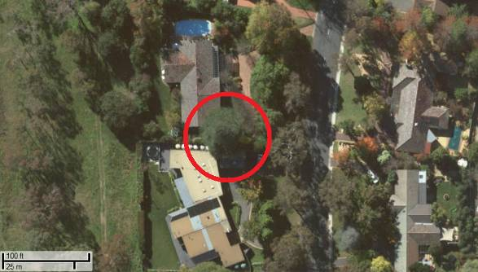
- The tree is located in the front yard of 54 Mugga Way Red Hill.

Specific Conditions
- Regular inspections should be undertaken by a qualified arborist to ensure the tree remains in good condition. (Five-year intervals would be considered appropriate).
- Minor pruning is permitted if undertaken within the Australian Standard, Pruning of Amenity Trees AS 4373-2007 and complies with the minimum level of pruning indicated under the provisions of the Tree Protection Act 2005. Any major pruning should be referred to the Tree Protection Unit for advice.
- Lopping is not permitted.
- The installation of irrigation should not include trenching within 5 metres of the natural canopy of the tree. Above ground dripper systems are permitted.
- Any pruning or proposed groundwork which may affect the health of the tree or requires work greater than the conditions listed shall be brought to the attention of the Tree Protection Unit for further assessment.
- Any development proposal which may affect the health of the tree shall be brought to the attention of the Tree Protection Unit for further assessment.
- Watering the tree will be left to lessee’s discretion. Restrictions will apply subject to ACTEW and the ACT Government guidelines. In circumstances where water restrictions apply the conditions outlined within the restrictions will prevail. Information regarding water conservation and current restrictions are available on the ACTEW web site.
Alan Traves
Conservator of Flora and Fauna 27/11/2013
AGREED

