Tree Registration

Nomination 92 PTR092-Group
Species: Quercus borealis (Red oak)
Location: Edkins Street Downer
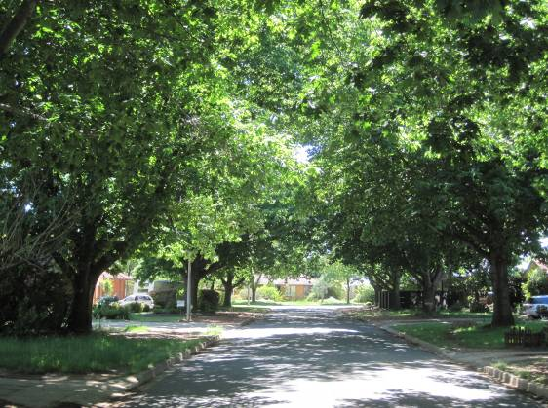
Location of Quercus borealis PTR092-Group in Downer 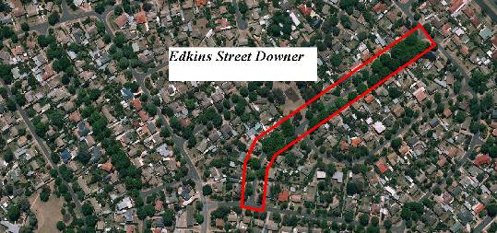

Criteria | Details of tree
Street address | Edkins Street Downer
Location on block | Located on the street verges
Botanical name: | Quercus borealis
Common name: | Red oak
Tree height | Predominantly 16.0m
Canopy broadest diameter: | 26.0m
Description of radial measurement | 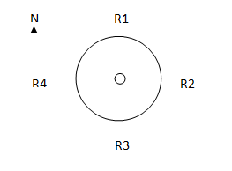
Canopy radial measurement | R1: 13.0m  R2: 13.0m  R3: 13.0m  R4: 13.0m
Trunk circumference: | 0.9-2.95m
Number of trunks: | 32 trees all with single trunks
Grid co-ordinates:  MGA 1994 | X 695,333.989 to 695,074.651  Y 6,098,212.886 to 6,097,969.339

Registration Criteria that presently apply, other criteria may apply after further assessment.
(2) Landscape and aesthetic value
The object of this value is to identify trees that are of particular importance to the community due to their substantial contribution to the surrounding landscape.
A tree may be considered to be of landscape and aesthetic value if it is situated in a prominent location when viewed from a public place and it:
(a) contributes significantly to the surrounding landscape based on its overall form, structure, vigour and aesthetic values; or
(b) represents an outstanding example of the species, including age, size or habit; or
(c) is an exceptional example of a locally native species that reached maturity prior to urban development in its immediate vicinity.
Statement against the Criteria
The Quercus borealis located in Edkins Street Downer have matured into an exceptional group of trees. The trees provide a significant landscape attribute in every season of the year. This ranges from the light green foliage of spring through to the dense canopies of summer, the outstanding colour of autumn and finally the sombre leafless appearance in winter. Every aspect of the trees’ yearly cycle represents a feature which produces an outstanding landscape feature. It is for this reason the trees have been nominated for inclusion to the ACT Tree Register. A rather interesting note should be added, during the planting of the trees two specimens of a different variety may inadvertently have been planted within the original stock of trees. This has not detracted from the avenue effect; contrary it allows the keen purveyor of plants to use their powers of observation to spot the interlopers within this fantastic street of beautiful trees.

Nomination 92
PTR092-Group
Quercus borealis (Red oak)

ACT Tree Register
(Registration)
Pursuant to Division 7.2 of the Tree Protection Act 2005 as the Conservator of Flora and Fauna the following decision has been made under section 52(1) to enter or not enter the above tree(s) to the ACT Tree Register

Registration

Yes
Penny Farnsworth
Conservator of Flora and Fauna 2/2/2014
Requests for further information should be made to:
Tree Protection Unit Telephone: (02) 6207 8145
PO Box 158 Facsimile: (02) 6207 5956
Canberra City, ACT 2601 Email: treeprotection@act.gov.au

