Tree Registration

Nomination 66 Tree Number PTR044
Species: Eucalyptus melliodora (Yellow Box)
Location: Block 15 Section 89 Banks
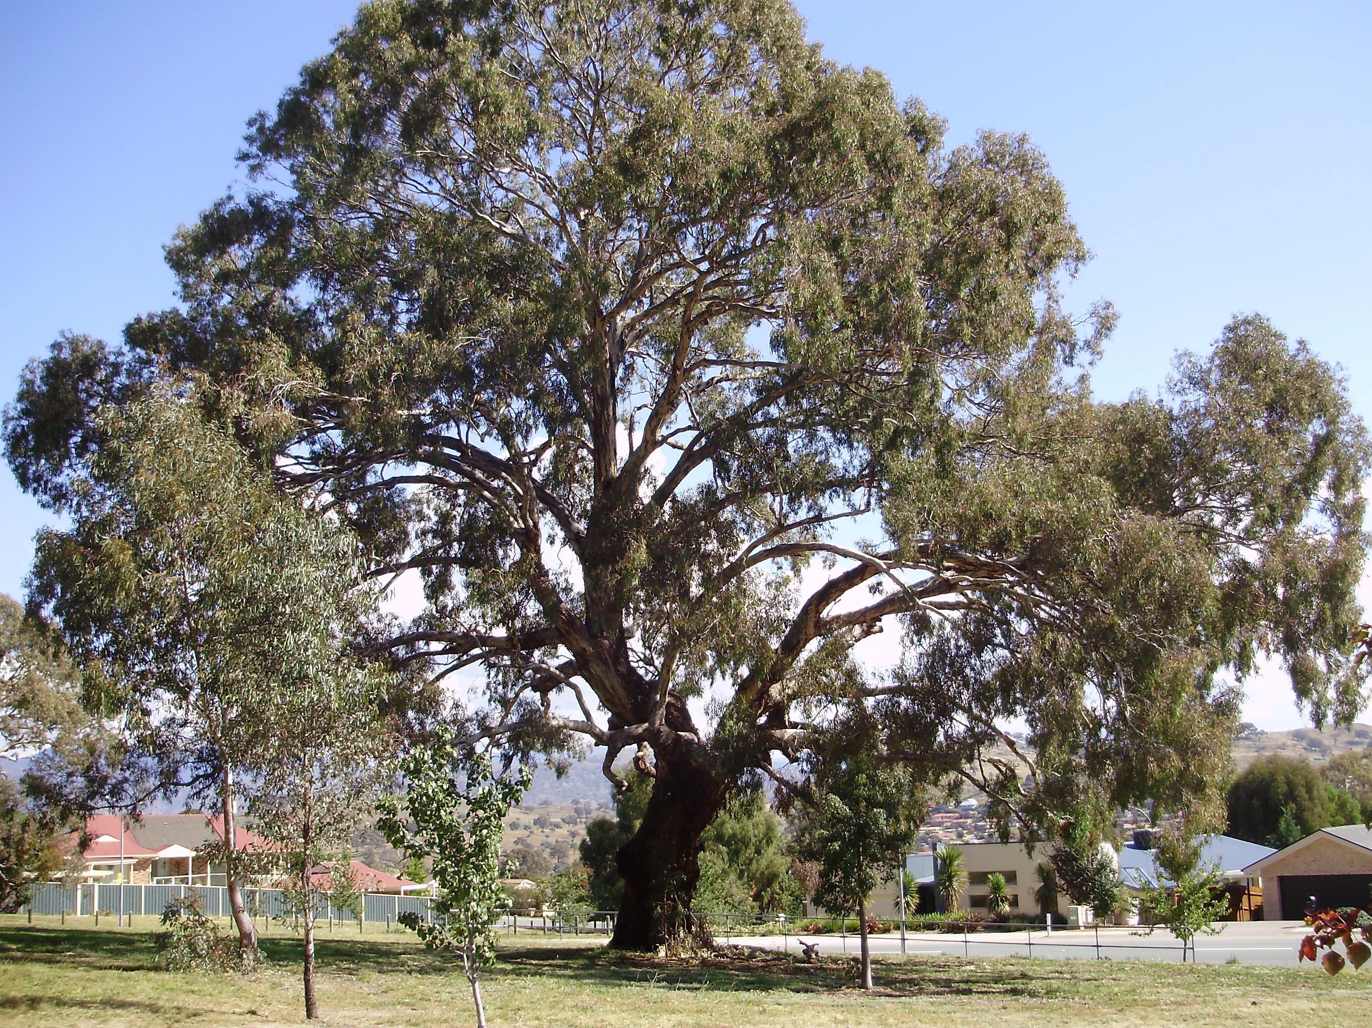
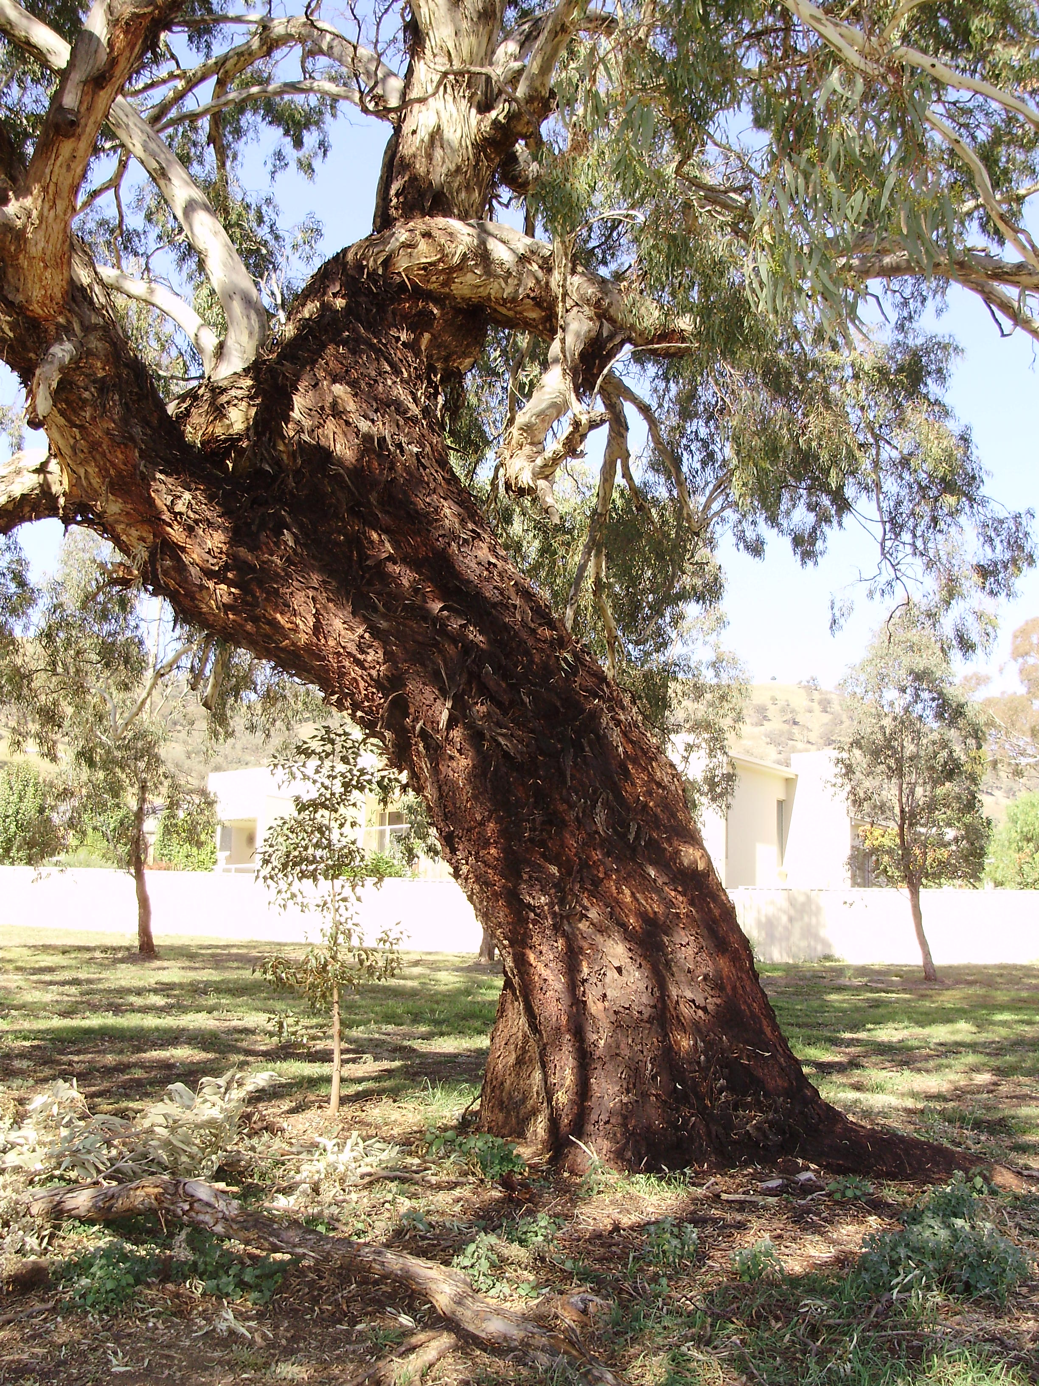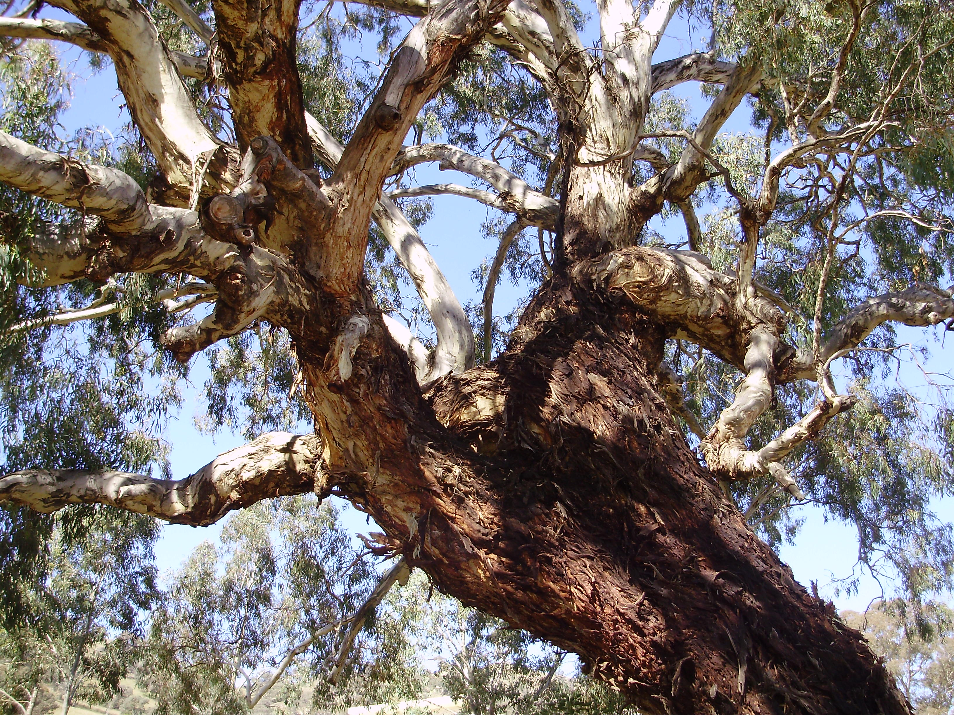
Location of Eucalyptus melliodora PTR044 in Banks
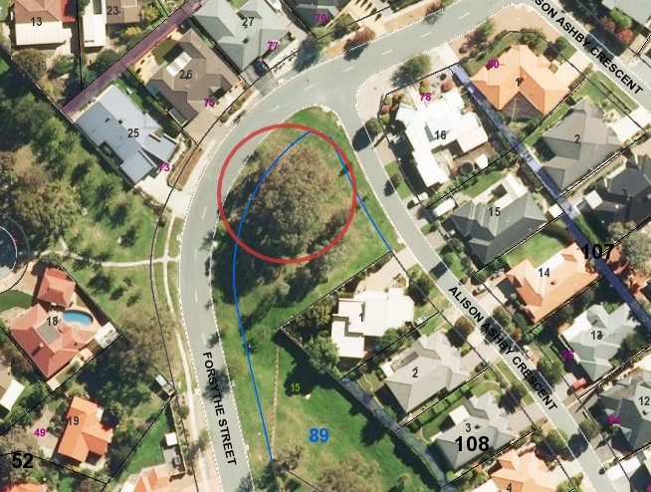

Criteria | Details of tree
Street address | Corner of Forsythe and Alison Ashby Crescent Banks.
Location on block | Located on urban open space in park land adjacent to Forsythe Crescent Banks.
Botanical name: | Eucalyptus melliodora
Common name: | Yellow Box
Tree height | 22.0m
Canopy broadest diameter: | 27.0m
Description of radial measurement | 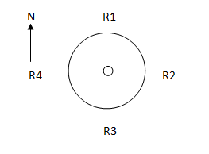
Canopy radial measurement | R1: 15.0m  R2: 13.0m  R3: 12.0m  R4: 9.0m
Trunk circumference: | 4.9m
Number of trunks: | 1
Grid co-ordinates:  MGA 1994 | X 690,643.817  Y 6,072,279.107

Registration Criteria that presently apply, other criteria may apply after further assessment.
(2) Landscape and aesthetic value
The object of this value is to identify trees that are of particular importance to the community due to their substantial contribution to the surrounding landscape.
A tree may be considered to be of landscape and aesthetic value if it is situated in a prominent location when viewed from a public place and it:
(a) contributes significantly to the surrounding landscape based on its overall form, structure, vigour and aesthetic values; or
(b) represents an outstanding example of the species, including age, size or habit; or
(c) is an exceptional example of a locally native species that reached maturity prior to urban development in its immediate vicinity.
Statement against the Criteria
This Eucalyptus melliodora (Yellow Box) has been well preserved since the establishment of the suburb, and has since created a focal point that is impossible to miss when driving past the small park in which it grows. The tree has all the attributes worthy of inclusion on the ACT Tree Register—it has a substantial girth, a huge canopy and is an old tree with plenty of character. It is not unusual to see a Eucalyptus melliodora with a low spreading crown but it is unusual to see a tree of this stature in a built up urban area. The following reasons are the most important when considering this tree for inclusion to the ACT Tree Register; overall form, size and aesthetic and habit value. This tree will become the suburb’s iconic tree and should provide many more years of useful life considering the effort made to preserve it within the original subdivision.

Nomination 66
Number PTR044
Eucalyptus melliodora (Yellow Box)

ACT Tree Register
(Registration)
Pursuant to Division 7.2 of the Tree Protection Act 2005 as the Conservator of Flora and Fauna the following decision has been made under section 52(1) to enter or not enter the above tree(s) to the ACT Tree Register

Registration

Yes
David Papps
Conservator of Flora and Fauna 18/3/2011
Requests for further information should be made to:
Tree Protection Unit Telephone: (02) 6207 8145
PO Box 158 Facsimile: (02) 6207 5956
Canberra City, ACT 2601 Email: treeprotection@act.gov.au

