Tree Registration

Nomination 111 Tree Number PTR111
Species: Eucalyptus blakelyi (Red Gum)
Location: Block 12 Section 154 Palmerston
Photo of tree:
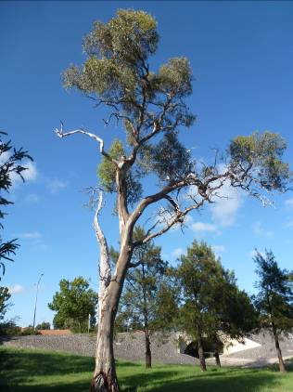
Photo showing location of Eucalyptus blakelyi PTR111 in Palmerston

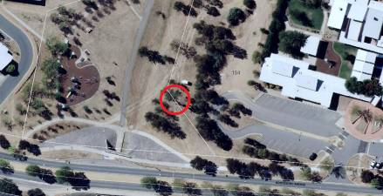
Criteria | Details of tree
Street address | 80 Kosciuszko Avenue Palmerston
Location on block | South–eastern side of the block, within the grounds of Palmerston Primary School
Botanical name: | Eucalyptus blakelyi
Common name: | Red gum
Tree height | 18.0m
Canopy broadest diameter: | 14.0m
Description of radial measurement | N  R1  R2  R4  R3
Canopy radial measurement | R1:8.0 m  R2: 7.0m  R3: 1.0m  R4: 7.0m
Trunk circumference: | 2.1m
Number of trunks: | 1
Grid co-ordinates:  MGA | E 209,937.170  N 613,171.412

Registration Criteria that presently apply, other criteria may apply after further assessment.
(2) Landscape and aesthetic value
The object of this value is to identify trees that are of particular importance to the community due to their substantial contribution to the surrounding landscape.

A tree may be considered to be of landscape and aesthetic value if it is situated in a prominent location when viewed from a public place and it:
(a) contributes significantly to the surrounding landscape based on its overall form.

(3) Scientific value
The object of this value is to identify trees that are of particular importance to the community due to values associated with their ecological, genetic or botanical significance or ability to substantially contribute to the scientific body of knowledge and understanding.

A tree may be considered to be of scientific value when it:
(e) is a significant habitat element for a threatened native species.

Statement against the Criteria
This over mature remnant Eucalyptus blakelyi has been selected for inclusion to the ACT Tree Register because of the landscape and ecological contributions it provides within the suburb of Palmerston. The tree is one of the last remnants which pre-existed development within the suburb. Whilst the tree may not appear to be in exceptional condition it does provide a significant contribution in relation to habitat values.
The tree attracts a significant number of local endemic bird species as well as some undesirable introduces species which squabble over the nesting hollows. Fortunately, Australian native parrots sometimes gain the upper hand and have the ability secure the hollows so they can raise their young.

Nomination 111
Number PTR111
Eucalyptus blakelyi (Red Gum)

ACT Tree Register
(Registration)
Pursuant to Division 7.2 of the Tree Protection Act 2005 as the Conservator of Flora and Fauna the following decision has been made under section 52(1) to enter or not enter the above tree(s) to the ACT Tree Register

Registration

Yes

Alan Traves
A/g Conservator of Flora and Fauna 08/03/2013

Requests for further information should be made to:

Tree Protection Unit Telephone: (02) 6207 8145
PO Box 158 Facsimile: (02) 6207 5956
Canberra City, ACT 2601 Email: treeprotection@act.gov.au

